**Aboveground Tank Pumps-Electric  
115 Volt AC Pump with 807C Mechanical Meter  
FR701V**

This rugged, positive displacement, heavy duty pump is UL listed. Explosion proof UL listed 1/3 HP motor (115 VAC-60Hz) with sealed bearings, heavy duty switch, thermal overload protection and junction box. Carbon vanes and ceramic/carbon seals reduce wear and repair expense. Integral check valve with pressure relief on outlet side reduces pressure drop and improves vertical lift. Easy removable strainer, automatic bypass valve, 2" threaded bung for tank openings.

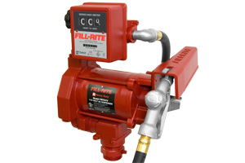 **115 Volt AC Pump with Manual Nozzle  
FR700V**

This rugged, positive displacement, heavy duty pump is UL listed. Explosion proof UL listed 1/3 HP motor (115 VAC-60Hz) with sealed bearings, Heavy Duty switch, thermal overload protection and junction box. Carbon vanes and ceramic/carbon seals reduce wear and repair expense. Integral check valve with pressure relief on outlet side reduces pressure drop and improves vertical lift. Easy removable strainer, automatic bypass valve, 2" threaded bung for tank openings.

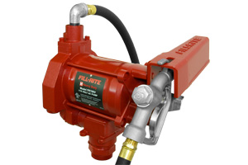

**115/230V High Flow AC Pump, 1”X12’ Hose, 1” Manual Nozzle  
FR310V**

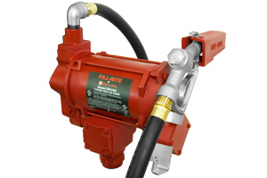

High Flow AC Utility Rotary Vane Pumps Series 300 with a flow rate few pumps can match, this pump provides long life. Explosion-proof UL listed dual voltage 3/4 HP motor (115 and 230 VAC) Motor has sealed bearings, heavy-duty switch and thermal overload protection, built-in junction box, cast iron pump housing with iron rotor and carbon vanes, check valve, pressure relief valve and strainer assembly, Automatic bypass valve, 2" threaded bung for tank openings. 1" Manual Nozzle. 2 Year Warranty.

**Aboveground Tank Pumps-Electric  
115/230V High Flow AC Pump ¾ HP UL Motor, 901 Meter, 1”X 12’ Hose, 1” Manual Nozzle  
FR311V**

High Flow AC Utility Rotary Vane Pumps. With a flow rate few pumps can match. the FR311V has an open flow rate of 30 GPM. This pump provides long life. Explosion-proof UL listed dual voltage 3/4 HP motor (115 and 230 VAC). Motor has sealed bearings, heavy-duty switch and thermal overload protection. Built-in junction box cast iron pump housing with iron rotor and carbon vanes check valve, pressure relief valve and strainer assembly, automatic bypass valve, 2" threaded bung for tank openings. 901 Meter included, 1" Manual Nozzle. 2 Year Warranty.

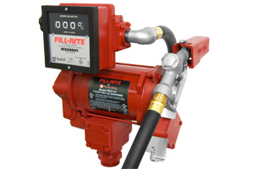

**12 Volt DC Pump with Manual Nozzle  
FR1210C**

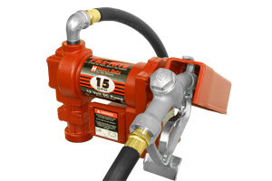 **12 Volt DC Pump with 807C Meter  
FR1211C**

This industry standard DC pump dispenses up to 15 GPM (57 LPM). The FR1210C is ideal for pumping gas, diesel fuel and kerosene. With an amp draw that's easy on your DC power source. Explosion-proof UL/cUL listed 1/4 HP motor. The FR1210C comes complete with 12' static wire hose and manual nozzle.

This industry standard DC pump dispenses up to 15 GPM (57 LPM). The FR1211C is ideal for pumping gas, diesel fuel and kerosene. With an amp draw that's easy on your DC power source. Explosion-proof UL/cUL listed 1/4 HP motor. The FR1211C comes complete with an 807C meter, 12' static wire hose and manual nozzle.

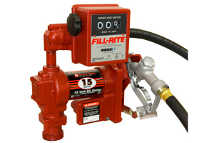

**Aboveground Tank Pumps-Electric  
12V DC Hi-Flow Pump with Manual Nozzle  
FR4210D**

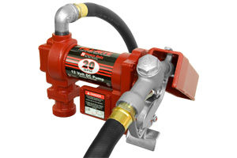 **12V DC Hi-Flow Pump with 901 Meter and Manual Nozzle  
FR4211D**

Contractor-grade, industry-standard Fill-Rite pump has an explosion-proof motor with permanent magnet. Steel suction pipe telescopes from 22in. to 40in. Features built-in check valve and strainer, hose with static ground wire and thermal overload protection. Manual nozzle included. Padlockable. UL listed. U.S.A.

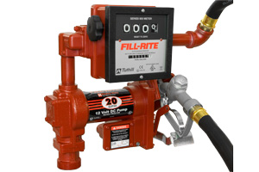

Contractor-grade, industry-standard Fill-Rite pump has an explosion-proof motor with permanent magnet. Steel suction pipe telescopes from 22 in. to 40 in. Features built-in check valve and strainer, hose with static ground wire and thermal overload protection. Comes complete with a 901 Meter and Manual Nozzle. Padlockable. UL listed. U.S.A.

**Aboveground Tank Pumps-Electric  
FR3210B**

When the job takes you off the beaten path, and you need a fuel-transfer pump that's durable, reliable, lightweight, easy to use—and very fast—you need the brand-new Fill-Rite 3200 Series Pump. With the fastest flow rate of any DC fuel-transfer pump on the market, our FR3200 Series makes filling tanks at remote job sites quicker and more efficient.

Delivering 25 gallons per minute, the FR3200 can fill a 500 gallon tank in just 20 minutes. And because it weighs less than 50 pounds, the FR3200 makes your operation highly mobile. The FR3200 is built strong to provide long-lasting reliability in the most demanding off-road environments. Put it all together, and you'll enjoy less downtime, greater productivity, and a greater return on your efforts.

The FR3200 Series offers two options: the FR3204 (pump only) and the FR3210B, which includes a 1-inch ultra-high-flow automatic nozzle and an 18-foot, 1-inch hose with a static wire. Fill-Rite also offers a wide range of accessories that can make your job even easier. The FR3200 is compatible with our 900D and 901 Series meters. Speed, mobility, flexibility, reliability—the FR3200 brings it all to the job. And best of all, it's a Fill-Rite, the best value in the pump industry, made right here in the USA.

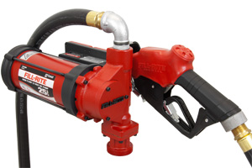

**Meter Cabinet  
FR902CRU**

Fill-Rite’s FR902C model meter cabinets are constructed from heavy duty 15-gauge steel and are powder coated to stand up to the harshest environments. Hood removal is quick and simple; remove three screws and the reset knob and you have access. The cabinet is pulser-ready and all external wiring connections are placed in easy access locations.

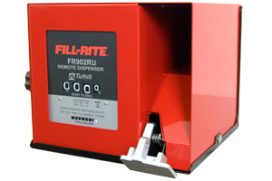

**Aboveground Tank Pumps- Electric  
M-180S 12-Volt DC Fuel Pump**

[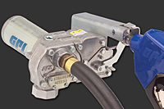](http://catalog.gpi.net/viewitems/electric-pumps/m-180s-pumps?&plpver=1001)

12 volt pump delivers up to 18 GPM.  
 Available with or without meter.

**M-3025/M-3425**

[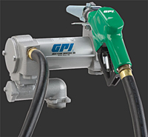](http://catalog.gpi.net/viewitems/electric-pumps/heavy-duty-vane-pumps?&plpver=1001) **M-3120 115 Volt AC Heavy Duty Fuel Pump and Fuel Meter Combos**

12 volt high performance transfer pump, delivers up to 25 GPM.   
Available with or without meter.

|  |
| --- |
| http://catalog.gpi.net/plp/mm/spacer.gif |

[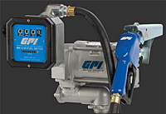](http://catalog.gpi.net/viewitems/electric-pumps-115-230-volt/heavy-duty-vane-pump-fuel-systems-combos-?&plpver=1001)

115 Volt electric transfer pump. 20 GPM, Available with or without a meter.   
Available in 115 Volt and 230 Volts.

**M-3130 115-Volt AC & 230-Volt AC Fuel Pump & Fuel Meter Combos**

[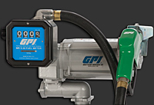](http://catalog.gpi.net/viewitems/electric-pumps-115-230-volt/super-heavy-duty-vane-pump-fuel-systems-combos-?&plpver=1001)

115 Volt electric transfer pump. 30 GPM, Available with or without a meter.  
 Available in 115 Volt and 230 Volts.

**Pumps and Remote Dispensers  
FR902RU** **115V AC Pumps for use with AST Remote Dispensers  
FR713V**

This Heavy-Duty, positive displacement pump delivers from 18 GPM (114 LPM) and is designed with Fill-Rite's exclusive anti-siphon safety feature. For flexible and convenient applications, combine above ground pumps with Series 305 or 307 remote dispensers, Explosion-proof UL/cUL listed motors. Systems are UL/cUL listed as well. Motor has sealed bearings, heavy-duty switch and thermal overload protection, built-in junction box, integral check valve, pressure relief valve and strainer. Cast iron pump housing with iron rotor, Automatic bypass valve, Anti-siphon device, 2" threaded base for tank openings.

The 902R Series features ¾ elbow in junction box so pulser can be wired directly into junction box. It has a new opening to accommodate pulser wiring. Comes with two openings in junction box, which now has ¾” for easier wiring. Offers a 4 digit mechanical register, 6GPM-40GPM, heavy duty materials, powder coat finish, and a universal nozzle boot. It is compatible with diesel fuel, gasoline and gasoline/alcohol blends (up to 10% ethanol), fuel oil, and lubricating oil (up to 60W lubricating oil; not temperature dependent.)

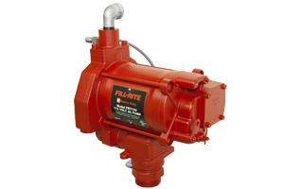

**115/230V for use with AST Remote Dispensers  
FR313V**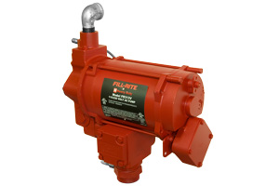

High Flow AC Utility Rotary Vane Pumps. The 313V has an open flow rate of 20 GPM. This pump provides long life. Explosion-proof UL listed dual voltage 3/4 HP motor (115 and 230 VAC) Motor has sealed bearings, heavy-duty switch and thermal overload protection, built-in junction box, cast iron pump housing with iron rotor and carbon vanes, check valve, pressure relief valve and strainer assembly. Automatic bypass valve, 2" threaded bung for tank openings. 2 Year Warranty.

**Pumps and Remote Dispensers  
M-3120/M-3260 115-Volt AC and 230-Volt AC Heavy Duty Fuel Pumps**[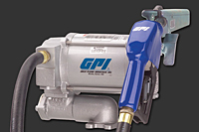](http://catalog.gpi.net/viewitems/electric-pumps-115-230-volt/m-3120-heavy-duty-vane-pumps?&plpver=1001) **M-3130 115-Volt AC and 230-Volt AC Super Heavy Duty Vane Pumps**

115 Volt, 20gpm, Electric fuel pump.   
Available with or without a meter.   
Available in 115 and 230 Volts.

[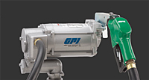](http://catalog.gpi.net/viewitems/electric-pumps-115-230-volt/super-heavy-duty-vane-pumps?&plpver=1001)

115 Volt, 30gpm, Electric fuel pump.   
Available with or without a meter.   
Available in 115 and 230 Volts.

**Fuel Remote Dispensers**[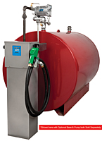](http://catalog.gpi.net/viewitems/remote-dispenser-drilldown/remote-dispensers?&plpver=1001)

Durable dispenser mounts on a fuel tank for easy refueling. Cabinet is powder-coated; nozzle cradle and nozzle cover are zinc plated for extra corrosion resistance. GPI's MR 5-30 Remote Dispenser can also be used with #126517-01 Pulser Kit (optional, sold separately).

**Hand Pumps  
Rotary Hand Pump Complete  
FR112**

Cast aluminum Fill-Rite pump provides smooth, continuous transfer of medium viscosity liquids, as well as oil, gasoline and diesel fuel. Improved seal keeps water out. Built-in check valve and strainer. Pump easily mounts to a standard drum with 2 in. NPT. Anti-siphoning device, hose with static wire and a 22in. to 40in. telescoping suction pipe. Padlockable pump can be set up for reverse flow and is adaptable for drums, kegs or storage tanks. U.S.A.

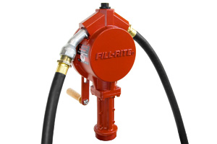 **Rotary Hand Pump, Telescoping Steel Suction Pipe, Pail Spout  
FR113**

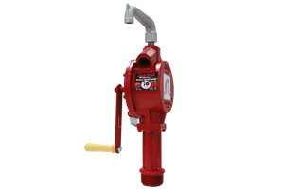

Cast aluminum Fill-Rite pump provides smooth, continuous transfer of medium viscosity liquids, as well as oil, gasoline and diesel fuel. Improved seal keeps water out. Built-in check valve and strainer. Pump easily mounts to a standard drum with 2 in. NPT. Anti-siphoning device, hose with static wire and a 22 in. to 40 in. telescoping suction pipe. Padlockable pump can be set up for reverse flow and is adaptable for drums, kegs or storage tanks. U.S.A.

**Hand Pumps  
Rotary Hand Pump Complete with Counter  
FR112C**

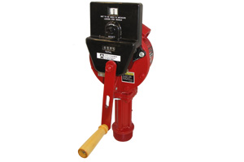

Cast aluminum Fill-Rite pump provides smooth, continuous transfer of medium viscosity liquids, as well as oil, gasoline and diesel fuel. Improved seal keeps water out. Built-in check valve and strainer. Pump easily mounts to a standard drum with 2 in. NPT. Anti-siphoning device, hose with static wire and a 22 in. to 40 in. telescoping suction pipe. Padlockable pump can be set up for reverse flow and is adaptable for drums, kegs or storage tanks. U.S.A.

**Piston Hand Pump with Steel Telescoping Tube and Nozzle Spout   
FR152**

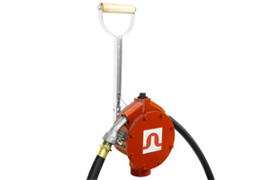

Fill-Rite Piston Pumps have an aluminum body with a stainless steel liner. Providing smooth, continuous transfer of medium viscosity liquids, as well as oil, gasoline and diesel fuel. Pump easily mounts to a standard drum with 2" NPT threaded tank adaptor. 20 gallons per 100 strokes. Made in the USA

**BP21X Superior Pump**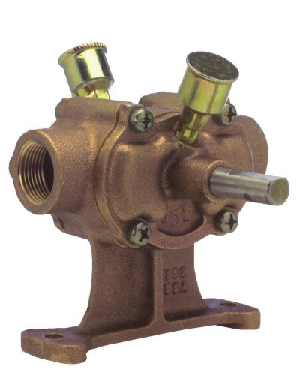

-Made of solid bronze to resist corrosion and handle some of the toughest material.  
-Has a 5/8” stainless steel drive shaft and 1” suction and discharge.   
-Can be driven by a ½ HP electric motor  
-28 Gallons per minute  
-Cast Bronze construction  
-Can be used to pump hundreds of chemicals

**Superior Pump 63X Replacement Impeller for BP21X**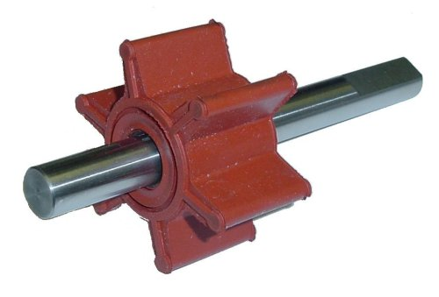

-Replacement impeller for BP21/BP21X  
-Can be used to pump hundreds of chemicals   
-Stainless steel impeller shaft  
-Chemical resistant rubber impeller  
-5/8” drive shaft